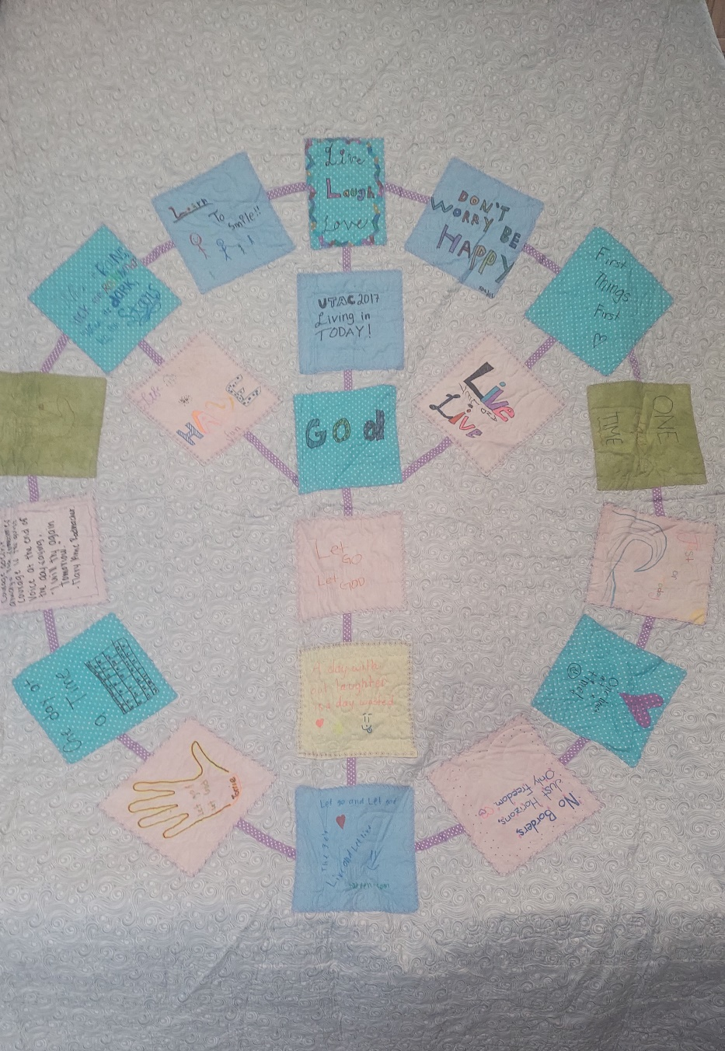UTAC Queen Size Quilt Opportunity Raffle 2025

All proceeds go to UTAC, to support Alateens at camp Which is a camp supporting kids who have been affected by someone else’s drinking or addiction.