**UTAC Registration Form**

**June 13 – 15, 2025**

**One form is needed for each person attending camp. The cost is $50 for a single day and $100 ($50 with scholarship) for the weekend. This includes all meals, cabins, events, and activities.**

**Registration Deadline is May 23th, 2025 Fill out one registration for each person attending.**

Name: ____________________________________________________________

Address: _____________________________________Phone:________________

City: ___________________________State: ____________Zip: _______________

Email: _______________________________________________ AGE: _________

Fellowship (circle one) Alateen: ______ Al-Anon: ______ AMIAS: _____ AA: _____

Gender (cabins) Male___________ Female____________ Age___________

Weekend Registration $100 ______________ $50 w/ Scholarship___________

Day Registration $50 ________________

If you are interested in a scholarship contact Jeff K. 801-916-2762 or Beverly J. 435-232-5047

**Registration is completed by mailing, emailing or texting each campers form to the address listed below along with payment. Please make checks payable to UTAC - PLEASE DO NOT SEND CASH.**

**You can pay via Venmo, at @Beverly-Jensen Attn: UTAC identifying all names attending.**

**Mail, Email or Text registration separately:** [**breosj@gmail.com**](mailto:breosj@gmail.com)**. Beverly J. 435-232-5047**

**Send one completed registration for each person attending**

**UTAC Registration C/O Beverly Jensen**

**236 W 400 S**

**Hyde Park, UT 84318.**

**Parents be aware we are requesting campers leave ALL their electronics at home. If for some reason they have electronics at camp unless previously approved, staff will hold on to it and return it to them at the end of UTAC.**

**UTAC June 13-15th 2025**

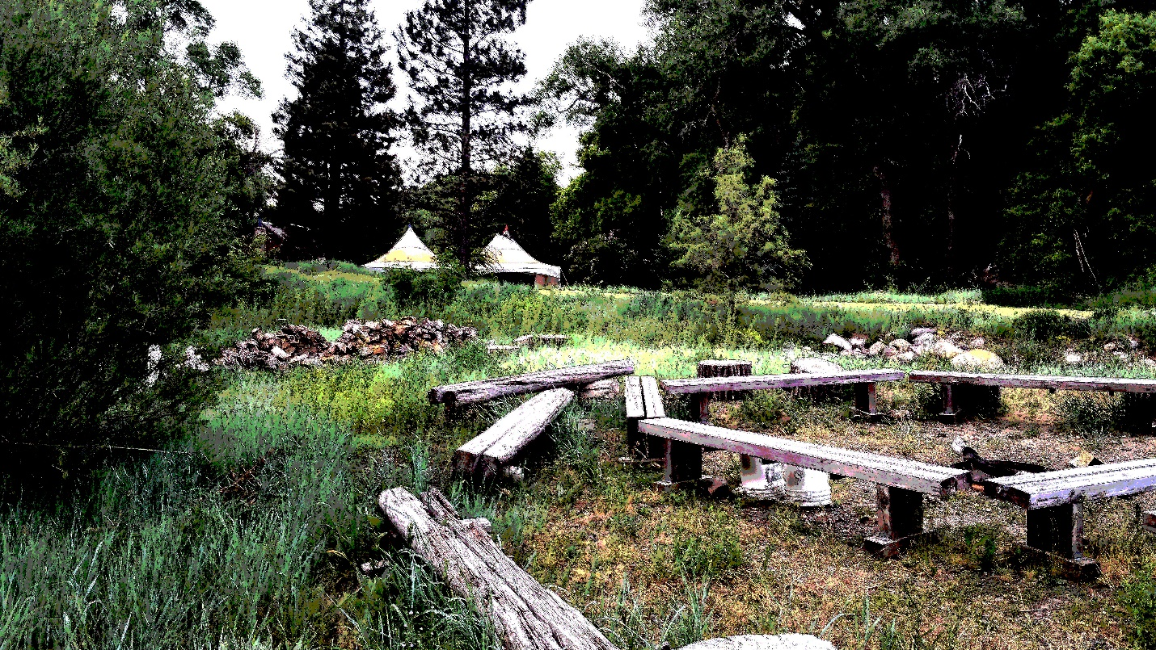

**UTAH ALATEEN CONFERENCE**

UTAC is a 2 night, 3 day summer recovery camp for adolescents’ who have been affected by a family member or friend’s alcoholism or addiction. The camp is located near Liberty Utah. To attend and sleep in the cabins you must be at least 7 years old. If younger children want to attend they may if their parents accompany them for the weekend. If you need help with the cost, UTAC has set up a scholarship fund, for more information please contact Beverly J at 435-232-5047 or Jeff K 801-916-2762

Donations appreciated, by groups or individuals. You may mail or Venmo them to @Beverly-Jensen Please identify yourself or Group Donation. Your donations are deeply appreciated so please send address so we can send you a thank you.

You may also send checks payable to:

UTAC Donations C/O Beverly Jensen 236 W 400 S Hyde Park, UT 84318.